Event Enquiry Form
Apply for an event in a Manchester Park

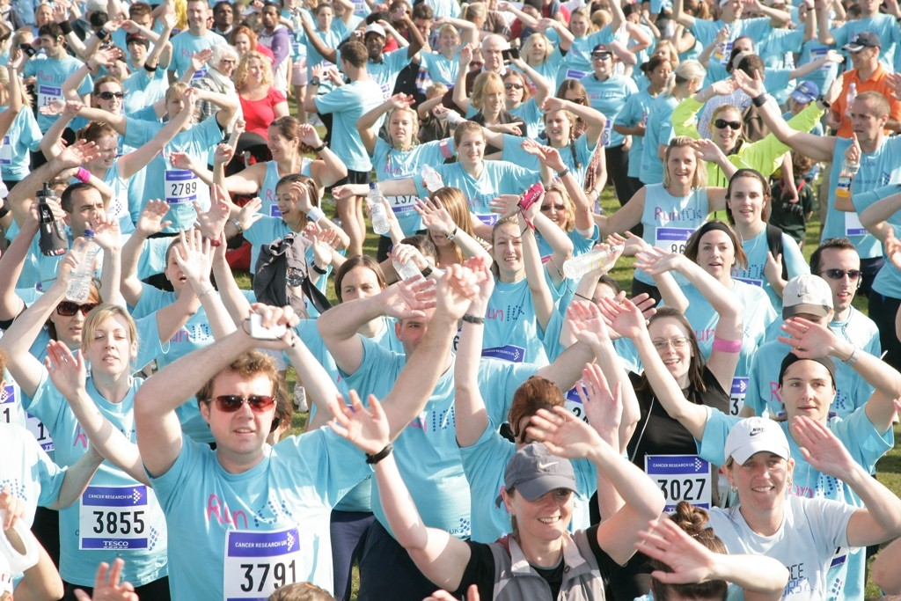

www.manchester.gov.uk
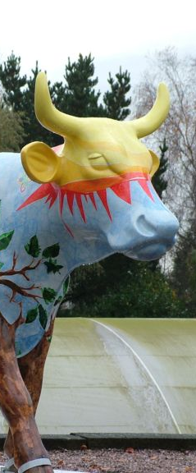

Your
Enquiry

We are happy for people to make use of our parks for public events however you will need to fill in this form to ensure that the event you are intending to run meets a range of criteria before being approved.

In considering your application we need to understand the type of event you wish to hold as we have two separate processes for small and large events.
Small Events
Typical examples of small events are: -
- A community family or fun day
- Fitness Groups
- A guided walk
- A community sports competition
- Sponsored Walks and Fun Runs
- One off small performing arts events such as outdoor opera or theatre production.

For a small event you will be required to provide the following information as part of your application:-

- A risk assessment

- Up-to-date Public Liability Insurance (£10m minimum)

- Agree to any terms and conditions, and payment of any fees for the use of MCC facilities

For Large scale events
For large scale events, depending on the content, we may require you to work with our Safety Advisory Group and this process can take up to 6 months. So be mindful to contact us early.
Typical examples of large scale events are:-
- Outdoor concerts
- Festivals
- Large sponsored runs and walks
- Large performing arts events
- Large-scale exhibitions
- Sports tournaments and festivals.
- Any event that would normally involve coordination with a variety of local authority employees and the emergency services or similar
For large events, the criteria which will need consideration (should the event be agreed in principle) are: -

- Adequate meetings leading up to your event with relevant MCC staff (or the Multi Agency Planning Group if required depending on size and nature of event)
- Full detailed Event Safety Management Plan and Risk Assessment including Site map, Operational Plan and Security / Stewarding plan.
- Signature and agreement of event contract.
- Adherence to premises license conditions.
- Adherence to conditions of use.
- Provision for security where applicable.
- Provision of adequate First Aid cover for your event.
- Provision of public liability insurance (£10m minimum).
- Agreement to provide information as requested by MCC or their representative.
- Agreement to pay a damage deposit for site re-instatement if requested by MCC or their representative.
- Agree to apply for relevant licenses.

Topics that need be considered when planning your event are detailed in the Health and Safety Guidance for Outdoor Events and The Event Safety Guide (HSG195) produced by the Health and Safety Executive.

If you wish to hold an event, please fill in the application below.
There is a charge for using our parks which is available on request.

.

Event Details

Name of event

Proposed location

Brief description of proposed event

/ /
/ /
/ /
Event proposed start date(s)

Start times each day

Finish times each day
/ /
Date for site for preparation
Date site will be vacated
/ /

Estimated Maximum Number of Persons Attending At any one time Overall attendance

Public

Staff/Performers
Contact Details

Name of organisation

Name of main contact

Address of main contact

Is this your invoice address? Yes □ No □ If no, please give details?

Email Mobile no.

Alternative phone no. Fax no.

Name of contact person on the day (if different from above)

Email Mobile no.
Are you a managing agent* on behalf of the event? Yes □ No □ If yes, please give details

*A managing agent is a third party person or organisation employed on behalf of the event.
For small events we recommend a notice period of approximately six weeks and large event six months. For events between May and September it is advisable to submit your application as early as possible as these dates are particularly in demand and availability is often limited.

Is your event organisation? Please tick one:-
Commercial □

Registered Charity □ Charity Number

Will all of the money raised go to the charity?  □yes □no

Educational Activity □ (This includes schools/college/universities)
Community event □ (This includes fundraising/ civic event/ religious event/ club event)

Have you held an event with the MCC before? Yes □ please give details No □

Name of event

Site of Event

Date of Event

Will you charge for the event? Yes □ No □ If yes, how much will you charge for a ticket?

Is your event open to the public? Yes □ No □
Do you have any sponsor interest for the event? Yes □ No □ If yes, please list them

How are you marketing your event? please give details

Promote your event in 200 words

Description of Activities
This section is very important to your application. It helps us to ensure you will have a successful and well-run event. If any of these details change it is up to you to inform us.
Have you assessed the event site? Yes □ No □
Do you have a site plan? Yes □ No □

Does you event involve any of the following licensable activities?

If you have tick any of the below boxes then you will be required, on approval of the application, to obtain the relevant event licence (Premise Licence or Temporary Event Notice) from Manchester City Council Licensing unit. For more information - http://www.manchester.gov.uk/info/200063/licences_and_permits.

□ Sale or Supply of Alcohol
If you plan on selling or supplying alcohol you must have a designated premises supervisor. For more information - https://www.gov.uk/alcohol-licensing.
□ Provision of Regulated Entertainment –
The means plays / films / indoor sporting events / boxing or wrestling entertainment / live music / recorded music / performance of dance / anything of a similar description.
□ Late Night Refreshment
Please note that late night refreshment is only licensable between 2300 and 0500.

In helping us further assess your application please tick the appropriate boxes to show the activities you intend to utilise or permit at the event? (Some of these may not be permitted at all sites).

Internal
□ Fireworks / Pyrotechnics □ Food / Drink Concession □ Carnival / Procession
□ Erecting banners □ Fairground Equipment □ Portable Staging
□ Lost Children Point □ Aircraft /Parachutists □ Barrier / Fencing
□ Marquees □ Balloon Launch □ Portable Generators
□ Animals □ Power Supply □ Motor Vehicles
□ Toilets □ Inflatables (i.e. Bouncy Castle)
□ Stewarding / Security □ On Site Communications □ P.A. System
□ Barbecue □ Bonfire □ Market Stalls / Gazebos
□ Re-enactment Groups □ Medical Provision □  Car Parking
□ Erecting banners □ Road Closures

Declaration
By returning this form, I confirm that the information provided is correct and I apply for permission to hold the event described on Manchester City Council land and does not constitute a confirmation of booking. I will adhere to the Equality Act (2010) and will not discriminate on the basis of race, colour, ethnic or national origins, religion and belief, gender, sexual orientation or marital status and disability or age.

Yes □ No □

Signed *

Name (block capitals)

Role at event

Date

Return form to: steven.garnett@manchester.gov.uk

